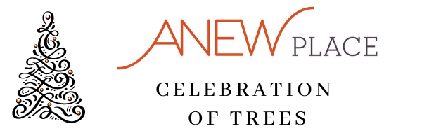
2021 SPONSORSHIP COMMITMENT FORM

Business name: _________________________________________________________________
Street Address: _________________________________________________________________
City: _____________________ State: _____________ Zip: ______________________________
Contact name: _________________________________________________________________
Telephone number (business): ________________________ Fax number: _________________
Email: __________________________________ Web address: __________________________

COMMITMENT LEVEL
$5,000 – Presenting $2,500 – Gold $1,000 – Silver $500 - Bronze

METHOD OF PAYMENT
Enclosed is my sponsorship check in the amount of $ ________________________________
Please an invoice to: __________________________________________________________

Please return form to the address below:
ANEW Place
P.O. Box 1481
Burlington, VT 05402
Reference: Celebration of Trees

Federal Tax ID # 03-0287599

